1. For a business, a supplier
A) is a company or individual that owns shares of the business.
B) is a company or individual to whom the business sells goods or services.
C) provides goods and services used by the business.
D) makes loans to the company to help finance its activities.
E) None of the above is correct.
2. A group of people establishing a business might prefer to set it up as a corporation rather
than a partnership
A) to have limited liability.
B) to avoid double taxation.
C) because of ease of formation.
D) because a corporation is considered to be a separate business entity and a partnership is
not
E) Both A and D are correct.
3. The ending retained earnings balance of Juan's Mexican Restaurant chain increased by $4.5
billion from the beginning of the year. The company had declared a dividend of $1.9 billion
during the year. What was the net income earned during the year?
A) $2.6 billion
B) $4.5 billion
C) $6.4 b illion
D) There is no way to determine net income as not enough information was given.
4. The collection of an account receivable from a customer would
A) Increase liabilities.
B) Decrease liabilities.
C) Not affect liabilities.
D) Decrease stockholders' equity.
E) None of the above is correct.
5. When a company buys equipment for $60,000 and pays for one third in cash and the other
two thirds is financed by a note payable, the following are the effects on the equation
A) cash decreases by $20,000
B) equipment increases by $60,000
C) liabilities increase by $40,000
D) total assets increase by $40,000
E) All of the above effects occur on the equation
6. The duality (or duality of effects) concept states
A) there is more than one way of looking at any situation.
B) every transaction has good and bad ramifications.
C) there are two entities involved in every transaction.
D) every transaction has at least two effects on the accounting equation.
E) None of the above is correct.
7. Rarro Corporation received $50,000 cash invested by its owners. The effect on the
fundamental accounting model was
A) assets and liabilities each increased by $50,000.
B) assets and revenues each increased by $50,000.
C) stockholders' equity and revenues each increased by $50,000.
D) stockholders' equity and assets each increased by $50,000.
E) stockholders' equity and liabilities each increased by $50,000.
8. Borrowing $100,000 of cash from First National Bank would
A) increase cash by a credit and increase notes payable by a debit.
B) increase notes payable by a debit and increase cash by a debit.
C) increase notes payable by a credit and increase cash by a debit.
D) decrease cash by a debit and decrease notes payable by a credit.
E) None of the above would occur.
9. Which of the following liability accounts is usually not satisfied by payment ofcash?
A) Accounts payable
B) Unearned revenues
C) Taxes payable
D) All of the above are satisfied by paying cash
10. Which of the following would cause retained earnings to increase?
A) Sale of service on credit.
B) Sold shares of our company stock to investors.
C) Gain on the disposal of land and building.
D) Both A and C would increase retained earnings
E) All of the above would increase retained earnings.
11. A landlord received $600 cash for December 20C's rent but the tenant's rent for
December is $1,000. Which of the following is true for year ended 20C.
A) $600 would be reported on the statement of cash flows.
B) $400 would appear on the balance sheet as rent receivable.
C) $1,000 would appear on the income statement as rent revenue earned.
D) All of the above are true.
E) None of the above is true.
In 2001, Boeing Company reported total assets of $48,343 million and net sales of $58,198
million. In 2000, they reported total assets of $42,677 million and net sales of $51,321
million. Their 2001 asset turnover ratio was
A) 1.20
B) 1.28
C) 1.25
D) None of the above.

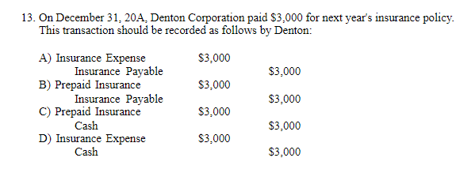
A) Entry A
B) Entry B
C) Entry C
D) Entry D

14. Typically, the largest, continuous cash inflow for a business will come from?
A) Sale of our stock to investors
B) Bank loans
C) Cash collected from customers
D) Cash interest received on our investments

15. Which of the following would most likely have the longest operating cycle?
A) Taco Bell restaurants
B) Aeronautical manufacturer Boeing
C) Motorcycle manufacturer Harley-Davidson
D) Safeway grocery stores.
16. On January 1, 20D, a two-year insurance policy was paid for in advance and debited to
prepaid insurance for $2,400; therefore; on December 31, 20D, the adjusting entry for the
expiration of this item should be a debit to insurance expense for $1,200 and a credit to cash
for $1,200.
A) True
B) False
17. The statement of stockholders' equity would not include
A) Net income.
B) Net sales.
C) Investments by owners for stock issued.
D) Dividends declared.
E) None of the above is correct.

18. Which one of the following accounts would not be closed at the end of the accounting year?
A) Rent expense.
B) Sales revenue.
C) Unearned subscriptions revenue.
D) Salaries expense.
E) All of the above would be closed.
19. When Lowry Company reports $120,000 of revenue and $130,000 of expenses for 20D, the
following is the effect:
A) Lowry's retained earnings is increased by the net income.
B) Lowry's contributed capital is increased by the net income.
C) Lowry's retained earnings decrease by the net loss.
D) Lowry's total stockholders' equity decreases by the net loss.
E) Both C and D occur.

20. Both the adjusting entries and the closing entries usually are dated as of the last day of the
accounting period.
A) True
B) False
21. When the receivables turnover ratio has decreased over the last year, it indicates less
effective management of the company's credit granting and collection activities.
A) True
B) False
22. Monitor Company's bank statement showed an ending balance of $10,000. Items appearing
in the bank reconciliation included: outstanding checks, $500; deposits in transit, $1,000;
bank service charges, $10; and Orange Company's check erroneously charged to Monitor's
bank account by the bank, $110. The correct cash balance at the end of the month should be
reported as
A) $10,600
B) $10,500
C) $11,610
D) $10,610

23. It is important to record sales returns and allowances in a separate account so management
can determine the volume of returns and allowances in order to measure the quality of their
products.
A) True
B) False
24. A company offers their credit customers terms of 3/10, n/60. This translates to an annual
interest rate of between 21 and 22%.
A) True
B) False
25. Outstanding checks that appear on a bank reconciliation are those checks issued during the
current statement period that have not yet cleared the bank during the current period.
A) True
B) False
26. A company has beginning inventory of $50,000, ending inventory of $35,000 and purchases
of $250,000. Therefore, its cost of goods sold is $235,000.
A) True
B) False
27. If a company has an increase in inventory equal to $3 million and a decrease in accounts
payable of $2 million, then cash flow from operating activities will decrease by $1 million.
A) True
B) False

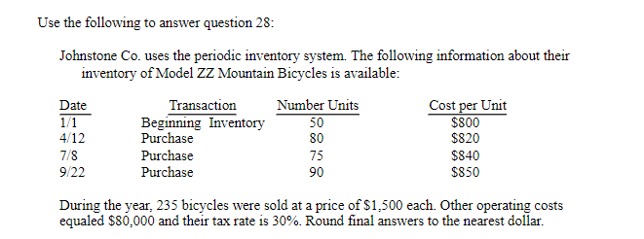

28. What was ending inventory and cost of goods sold on 12/31 under the LIFO cost flow
assumption?
A)$51,000 and $194,100
B)$48,200 and $196,900
C)$49,851 and $195,249
D)None of the above.

29. The cost of goods sold account is a/an:
A) asset.
B) contra asset.
C) extraordinary item.
D) liability
E) None of the above is correct.
30. With a perpetual inventory system, we track both the units and costs of beginning inventory,
purchased inventory and inventory sold.
A) True
B) False
31. Companies cannot change the method of depreciation adopted for a group of assets.
A) True
B) False
32. Areollis Company recently purchased a truck. The price negotiated with the dealer was
$100,000. Areollis also paid sales tax of $8,000 on the purchase, shipping and preparation
costs of $6,000, and insurance for the first year of operation of $3,000. For the truck, what
amount should be debited to the asset account Vehicles?
A) $100,000.
B) $114,000.
C) $108,000.
D) $106,000.
E) $109,000.
33. Regardless of the method of depreciation used under generally accepted accounting
principles (GAAP), the ending book value will be the same at the end of the asset's useful
life.
A) True
B) False
34. In 20B, Gamma Company made an ordinary repair to a delivery truck at a cost of $300.
Gamma's accountant debited the asset account, Delivery Vehicles. Was this treatment an
error, and if so, what will be the effect on the financial statements of Gamma?
A) The repair was accounted for correctly.
B) The error increased assets and net income in 20B.
C) In the years following 20B, net income will be too high.
D) The error decreased net income in 20B.
E) Net income was correctly stated for 20B.
35. No clear line distinguishes capital expenditures (assets) from revenue expenditures
(expenses); therefore, it requires managers to exercise judgment in making a subjective
decision.
A) True
B) False
36. Because of its large investment in equipment, Delta Air Lines closely monitors the unused
seats on flights since it may be more profitable to reduce fares to fill more seats thereby using
more of the capacity.
A) True
B) False
37. The current ratio is the dollar difference between total assets and total liabilities.
A) True
B) False
38. A company that sells primarily on a cash basis could support a lower current ratio because
their cash inflow is faster than a company selling on credit.
A) True
B) False
39. On January 1, 20A, Ross Company acquired a truck that had a purchase price of $20,000.
The seller agreed to allow Ross to pay for the truck over a two-year period at 10% interest
with equal payments due at the end of 20A and 20B. The amount of each annual payment the
company must make is (round to the nearest dollar)
A) $22,267.
B) $11,524.
C) $14,151.
D) $17,751.
E) None of the above is correct.
40. A contingent liability that is “reasonably possible” but “cannot reasonably be estimated”
A) must be recorded and reported as a liability.
B) does not need to be recorded or reported as a liability.
C) must only be disclosed as a note to the financial statements.
D) must be reported as a liability, but not recorded.
41. A liability, to be reported on the balance sheet, must have a fixed, known amount to be paid
in the future.
A) True
B) False
42. Disney Company's accounts payable equaled $4,603 million in 2001 and was $5,163 million
in 2000. This change in accounts payable had a negative impact on cash.
A) True
B) False

43. Which of the following statements is false relating to payroll taxes?
A) When recording the payroll entry, the credit to wages payable is usually more than the
debit to wages expense.
B) FICA (social security) tax is a “matching” tax with the employer.
C) Income taxes withheld from employees' paychecks are liabilities of the employer.
D) When the salaries expense entry is recorded, the credit to cash will be for less than the
debit to salaries expense.
E) Two of the above statements are false.
In 2001, Toys “ R” Us had an accounts payable turnover ratio of 5.65; in 2000,
5.49 and 6.08 in 1999. Which statement is true about what the ratios indicate?
A) Toys “R” Us is taking longer to pay its vendors in 2001 versus 2000.
B) Toys “R” Us is taking more time to pay vendors in 2001 than in 1999.
C) Toys “R” Us has seen some weakening of its accounts payable turnover ratio but it has
not been a dramatic change.
D) Both B and C are true.
E) All of the above are true.
45. Amortization of a discount on a bond payable will make the amount of interest expense
reported on the income statement less than the cash paid for that year.
A) True
B) False
46. Bonds payable usually are classified on the balance sheet as
A) long-term liabilities.
B) current liabilities.
C) investments and funds.
D) current assets.
E) None of the above is correct.
47. When a company prepares a bond indenture, certain provisions of the bonds are included.
Which of the following are not provisions specified in the indenture?
A) Dates of interest payments.
B) Rate of interest to be paid.
C) Maturity date.
D) Cash to be received at the issue date.
E) All of the above are specified in the indenture.

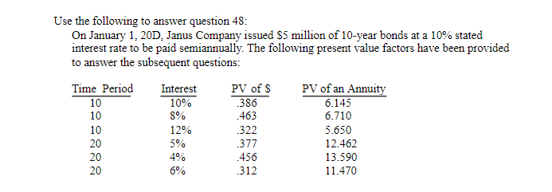

48. Calculate the issuance price if the market rate of interest is 12%.
A) $4,427,500
B) $4,477,500
C) $4,435,000
D) $5,000,000
49. A bond sold at a discount will pay total cash payments for interest that is more than the total
interest expense recognized over the period the bond is issued.
A) True
B) False
50. The balance sheet of Warner Company showed the following data about its common stock,
par $1: authorized shares, 5,000,000; outstanding shares, 2,300,000; and issued shares
2,500,000. Therefore, the number of treasury stock shares was
A) 0.
B) 2,700,000.
C) 2,500,000.
D) 200,000.
51. Which of the following statements is true?
A) An initial public offering (IPO) occurs when the company first offers their stock for sale
to the public.
B) A seasoned new issue is the term used for any additional sales of new stock to the public
after the IPO.
C) An underwriter, usually an investment banker, advises the corporation on matters
concerning the sale of shares of stock and helps to market those shares for a fee.
D) A and B are true.
E) All of the above are true.
52. A small stock dividend is generally defined as one involving the distribution of additional
shares that are more than 50% of the currently outstanding shares.
A) True
B) False
53. When a corporation calls in its outstanding shares and issues two or more shares with a lower
par value in place of each share called in, the corporation is said to have issued a stock split.
A) True
B) False
54. While all businesses are separate economic entities from their owners, only corporations are
separate legal entities with the right to own assets, incur liabilities, sue and be sued and enter
into contracts.
A) True
B) False
55. Which of the following are the typical rights afforded the preferred stockholders?
A) A preference to receive dividends when declared by the board of directors before common
stockholders can receive their dividends.
B) A preference to receive the liquidation value of the assets as stated in the stock contract
before common stockholders can receive their share.
C) The right to vote on major corporate issues including electing the board of directors.
D) Only A and B are preferred stockholder rights
E) All the above are preferred stockholder rights.
56. Which one of the following is a basic right of an owner of common stock?
A) Participation in the corporation by voting in stockholder meetings.
B) Participation in the profits of the corporation through dividends declared by the board of
directors.
C) Sharing in the distribution of assets of the corporation at liquidation.
D) Both A and B are rights.
E) All of the above are basic rights.
57. In 2001, Genentech had 535.3 million average common shares outstanding, actual shares
outstanding at year-end of 528.3 million and reported earnings per share of $.28. Genentech's
reported net income in 2001 equals
A) $149.9 million.
B) $147.9 million.
C) $148.9 million.
D) an amount that cannot be computed with the given information.
58. Increases in current liabilities are added to net income while decreases in current liabilities are subtracted from net income to derive the net cash flows.
A) True
B) False
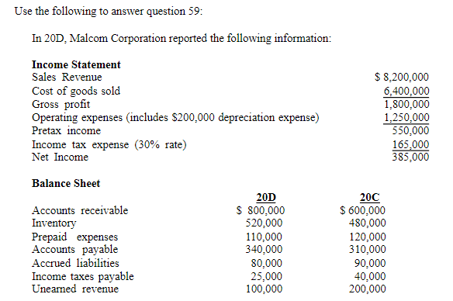

59. Malcom's cash paid for income taxes in 20D is:
A) 165,000
B) 180,000
C) 150,000
D) 135,000

60. The statement of cash flows (indirect method) reports depreciation expense as an addition to
net income because depreciation
A) causes an inflow of funds for the replacement of assets.
B) reduces reported net income of the period but does not involve an outflow of cash for that
period.
C) is a direct use of cash.
D) reduces reported net income and causes an inflow of cash.
E) None of the above is correct.
61. The capital acquisitions ratio takes cash flow from operations divided by property, plant and
equipment, net from the balance sheet.
A) True
B) False
62. The net cash inflow (or outflow) from operating activities is computed by adjusting the
reported accrual net income for noncash revenue and noncash expense items.
A) True
B) False
63. Investing activities must be disclosed under the gross method. Therefore, if a company paid
$200 million to acquire new equipment and sold old equipment for $25 million, then both
these items would be separately disclosed in the investing section of the statement of cash
flows.
A) True
B) False
64. The book value of the investment stock sold would show up as cash inflow from investing
activities.
A) True
B) False
65. The income statement, balance sheet and statement of cash flows all are prepared on the
accrual basis.
A) True
B) False
66. In 2001, Coca-Cola disclosed cash paid for property, plant and equipment of $769 million
and cash flow from operations of $4,110 million. Their average property, plant and
equipment from the comparative balance sheet was $4,311 million. Compute Coca-Cola's
capital acquisitions ratio for 2001.
A) .95
B) 5.34
C) 5.61
D) None of the above.
67. XYZ Co. bought stock in ABC Corporation. This would be reported as a cash outflow
connected to investing activities.
A) True
B) False
68. Which of the following statements about the statement of cash flows is correct?
A) The sale of an investment in bonds for less than the carrying value of the investment
would be reported as cash outflow from financing activities.
B) The sale and issuance of common stock for cash would be reported as a cash inflow from
investing activities.
C) The retirement of bonds payable by the issuance of common stock would be reported as a
cash inflow from investing activities.
D) Collecting cash interest revenue on a note receivable would be reported as a cash inflow
from investing activities.
E) None of the above is correct.
69. Which of the following statements about cash flows from operating activities, in a statement
of cash flows prepared under the indirect method, is correct?
A) An increase in accounts receivable would be subtracted from net income.
B) An increase in salaries payable would be subtracted from net income.
C) An increase in inventory would be added to net income.
D) Depreciation expense would be subtracted from net income.
E) None of the above is correct.

70. Custer Corporation reported the following information related to its common stock (par $10)
outstanding and net income:
Total stockholders’ equity (no preferred stock) - $125,000
Current market price per share of common stock - $40
Dividends declared and paid during 20F - $10,000
Balance in the common stock account - $35,000
Net Income $35,000
The price earnings ratio and dividend yield ratio is, respectively:
A) 4.57 and 6.25%
B) 4.26 and 6.77%
C) 4.57 and 6.77%
D) 4.26 and 6.25%

71. Which of the following statements is true?
A) When cost of goods sold as a percentage of sales increases the gross margin percentage
will increase.
B) It is possible for cost of goods sold in dollars to increase while cost of goods sold as a
percentage of sales decreases.
C) If gross margin percentage is the same for the current and past year, then sales and cost of
goods sold in dollars did not change.
D) Both B and C are true.
E) All of the above are true.
72. If accounts receivable are collected quickly,
A) the accounts receivable turnover is low.
B) the company's credit policies may be overly stringent.
C) credit is often granted to poor credit risks.
D) Two of the above are correct.
E) None of the above is correct.

73. The quick ratio of a company will always be less than or equal to the current ratio (working
capital ratio).
A) True
B) False

74. In 2004, Coca-Cola's gross profit ratio was 65.2% and their profit margin was 22.1%. In
2004, PepsiCo's gross profit ratio was 54.2% and their profit margin was 14.4%. Which of
the following is false?
A) Coca-Cola's cost of goods sold was a lower percentage of sales than PepsiCo's.
B) In 2004, Coca-Cola's profit margin was 53% greater than PepsiCo's which would be
explained as a higher return on sales.
C) The major reason for PepsiCo's lower profit margin is that their selling, general and
administrative expenses were double the percentage of sales compared to Coca-Cola's
percentage of sales.
D) All of the above are false.
E) None of the above is false.
75. The effective (market) interest rate is less than the stated interest rate on bonds that sell at a
premium.
A) True
B) False

